Simulation of chemical reaction dynamics on an
NMR quantum computer
Dawei Lu¹, Nanyang Xu¹, Ruixue Xu¹, Hongwei Chen¹, Jiangbin Gong^{2, 3}, Xinhua Peng¹, and Jiangfeng Du¹,
¹Hefei National Laboratory for Physical Sciences at Microscale and Department of Modern Physics, University of Science and Technology of China, Hefei, Anhui 230026, People’s Republic of China
²Department of Physics and Centre for Computational Science and Engineering, National University of Singapore, 117542, Republic of Singapore
³NUS Graduate School for Integrative Sciences and Engineering, 117597, Republic of Singapore
Quantum simulation can beat current classical computers with minimally a few tens of qubits and will likely become the first practical use of a quantum computer. During the past years several quantum simulation algorithms designed for individual problems were proposed¹⁻⁵ and a part of them have been realized using physical systems such as nuclear-magnetic-resonance (NMR)⁶⁻⁸ or trapped-ions⁹. One key application of quantum simulation will be in quantum chemistry. Aspuru-Guzik et al. and Kassal et al. proposed quantum simulation algorithms to calculate stationary molecular properties¹⁰ as well as chemical reaction rates¹¹, with the quantum simulation of the former experimentally implemented on both NMR¹² and photonic quantum computers¹³. More challenging is the quantum simulation of chemical reaction dynamics. Here we report an experimental demonstration that a small NMR quantum computer is already able to simulate the dynamics of a prototype chemical reaction. We conclude that the quantum simulation of chemical reaction dynamics not computable on current classical computers is feasible in the near future.
In addition to offering general-purpose quantum algorithms with substantial speed-ups over classical algorithms¹⁴ [e.g., Shor’s quantum factorizing algorithm¹⁵], a quantum computer can be used to simulate specific quantum systems with high efficiency¹⁶. This quantum simulation idea was first conceived by Feynman¹⁷. Lloyd proved that with quantum computation architecture, the required resource for quantum simulation scales polynomially with the size of the simulated system¹⁸, as compared with the exponential scaling on classical computers. Being most likely the first practical use of a quantum computer, quantum simulation has attracted substantial research interests.
Theoretical calculations of chemical reaction dynamics play an important role in understanding reaction mechanisms and in guiding the control of chemical reactions^{19, 20}. On classical computers the computational cost for propagating the Schrödinger equation increases exponentially with the system size. Indeed, standard methods in studies of chemical reaction dynamics so far have dealt with up to 9 degrees of freedom (DOF)²¹. Some highly sophisticated approaches, such as the multi-configurational time-dependent Hartree (MCTDH) method²², can treat dozens of DOF but various approximations are necessary. So generally speaking, classical computers are unable to perform dynamical simulations for large molecules. For example, for a 10–DOF system and if only 8 grid points are needed for the coordinate representation of each DOF, classical computation will have to store and operate 8¹⁰ data points, already a formidable task for current classical computers. By contrast, such a system size is manageable by a quantum computer with only 30 qubits. Furthermore, the whole set of data can be processed in parallel in quantum simulation. For these reasons the quantum simulation of chemical reaction dynamics is of significance to both fields of quantum chemistry and quantum physics.
In this report we demonstrate that the quantum dynamics of a laser-driven hydrogen transfer model reaction can be captured by a small NMR quantum simulator. Given the limited number of qubits, the potential energy curve is modeled by 8 grid points. The continuous reactant-to-product transformation observed in our quantum simulator is in remarkable agreement with a classical computation based also upon an 8-dimensional Hilbert space. To our knowledge, this is the first explicit implementation of the quantum simulation of a chemical reaction process. Theoretical methods and general experimental techniques described in this work should motivate next-generation simulations of chemical reaction dynamics with a larger number of qubits.
Previously we were able to simulate the ground-state energy of Hydrogen molecule¹². Here, to simulate chemical reaction dynamics, we consider a one-dimensional model of a laser-driven chemical reaction²³, namely, the isomerization reaction of nonsymmetric substituted malonaldehydes, depicted in Fig. 1a. The system Hamiltonian in the presence of an external laser field is given by
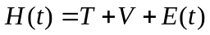 with 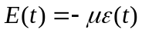. (1)
In Eq. (1), E (t) is the laser-molecule interaction Hamiltonian,μ= eq is the dipole moment operator, 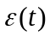 represents the driving electric field, 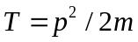 is the kinetic energy operator, and
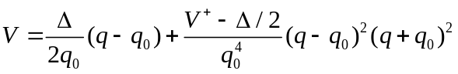 (2)
is a double-well potential of the system along the reaction coordinate. In Eq. (2) V⁺ is the barrier height, gives the asymmetry of the two wells, and ±q₀ give the locations of the potential well minima. See the figure caption of Fig. 1b for more details of this model.
We first employ the split-operator method^{24, 25} to obtain the propagator U (t + δt, t) associated with the time interval from t to t + δt. We then have
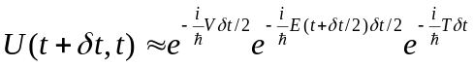
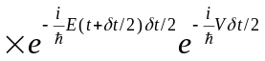. (3)
The unitary operator 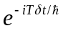 in Eq. (3) is diagonal in the momentum representation whereas all the other operators are unitary and diagonal in the coordinate representation. Such U (t + δt, t) can be simulated in a rather simple fashion if we work with both representations and make transformations between them by quantum Fourier transform (QFT) operations. To take snapshots of the dynamics we divide the reaction process into 25 small time steps, with δt = 1.5 fs and the total duration t_{f} = 37.5 fs. The electric field of an ultrashort strong laser pulse is chosen as
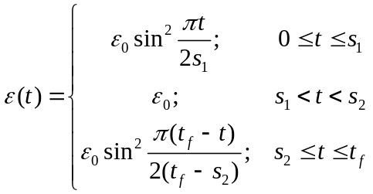 (4)

with s₁ = 5 fs and s₂ = 32.5 fs. More details, including an error analysis of the split-operator technique, are given in the supplementary material. The reactant state at t = 0 is assumed to be the ground-state 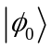 of the bare Hamiltonian T + V, which is mainly localized in the left potential well. The wavefunction of the reacting system at later times is denoted by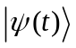. The product state of the reaction is taken as the first excited state 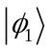 of T + V, which is mainly localized in the right potential well.
With the system Hamiltonian, the initial reactant state, the product state, and the propagation method outlined above, the next step is to encode the time-evolving wavefunction and the T, V, E (t) operators by n qubits. To that end we first obtain the expressions of these operators in representation of a set of 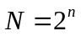 discretized position basis states. The evolving state can then be encoded as
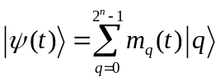
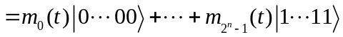, (5)
and as a result the system operators become
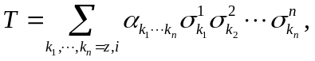 (6)
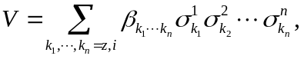 (7)
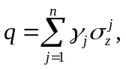 (8)
where 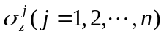 is the Pauli matrix and 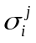 is the N-dimensional identity matrix. Because our current quantum computing platform can only offer a limited number of qubits and the focus of this work is on an implementation of the necessary gate operations under the above encoding, we have employed a rather aggressive 8-point discretization using n = 3 qubits. The associated diagonal forms of the T, V, and q matrices are given in the supplementary material. In particular, the end grid points are at q = ±0.8 Å and the locations of other 6 grid points are shown in Fig. 1b. The eigenvalues of the ground and first excited states of the bare Hamiltonian treated in the 8-dimensional encoding Hilbert space are close to the exact answers. The associated eigenfunctions are somewhat deformed from exact calculations using, e.g., 64 grid points. Nonetheless, their unbalanced probability distribution in the two potential wells is maintained. For example, the probability for the first excited state being found in the right potential well is about 80%.
In our experiment qubits 1, 2, and 3 are realized by the ¹⁹F, ¹³C, and ¹H nuclear spins of Diethyl-fluoromalonate. The structure of Diethyl-fluoromalonate is shown in Fig. 2a, where the three nuclei used as qubits are marked by oval. The internal Hamiltonian of this system is given by
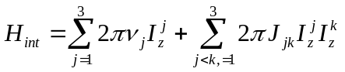, (9)
where 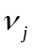 is the resonance frequency of the jth spin and J_{jk} is the scalar coupling strength between spins j and k, with J₁₂ = −194.4 Hz, J₁₃ = 47.6 Hz, and J₂₃ = 160.7 Hz. The relaxation time T₁ and dephasing time T₂ for each of the three nuclear spins are tabulated in Fig. 2b. The experiment is conducted on a Bruker Avance 400 MHz spectrometer at room temperature.
The experiment consists of three parts: (A) Initial state preparation. In this part we prepare the ground state of the bare Hamiltonian T + V as the reactant state; (B) Dynamical evolution, that is, the explicit implementation of the system evolution such that the continuous chemical reaction dynamics can be simulated; (C) Measurement. In this third part the probabilities of the reactant and product states associated with each of the 25 snapshots of the dynamical evolution are recorded. For the jth snapshot at 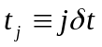, we measure the overlaps 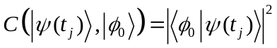 and 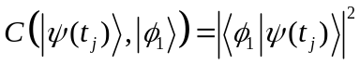, through which the continuous reactant-to-product transformation can be displayed. The main experimental details are as follows. Readers may again refer to the supplementary material for more technical explanations.
(A) Initial State Preparation. Starting from the thermal equilibrium state, firstly we create the pseudo-pure state (PPS) 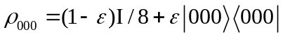 using the spatial average technique²⁶, where 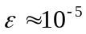 represents the polarization of the system and I is the 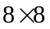 identity matrix. The initial state was prepared from 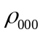 by applying one shaped radio-frequency (RF) pulse characterized by 1000 frequency segments and determined by the GRadient Ascent Pulse Engineering (GRAPE) algorithm²⁷⁻²⁹. The preparation pulse thus obtained is shown in Fig. 2c with the pulse width chosen as 10ms and a theoretical fidelity 0.995. Because the central resonance frequencies of the nuclear spins are different, Fig. 2c shows the RF field amplitudes vs time in three panels. To confirm the successful preparation of the state, we carry out a full state tomography and examine the fidelity between the target density matrix 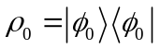 and the experimental one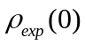. Using the fidelity definition 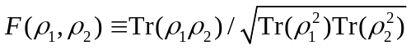, we obtain 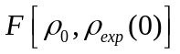= 0.950. Indeed, their real parts shown in Fig. 4a are seen to be in agreement.
(B) Dynamical Evolution. The reaction process was divided into 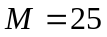 discrete time intervals of the same duration δt. Associated with the mth time interval, the unitary evolution operator is given by
, (10)
where U_{QFT} represents a QFT operation, and other operators are defined by 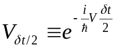, 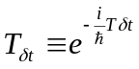, and 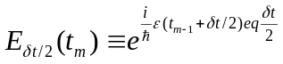, with V, T, and q all in their diagonal representations. Such a loop of operations is 𝑚-dependent because the simulated system is subject to a time-dependent laser field. The numerical values of the diagonal operators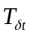, 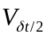 and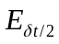 are elaborated in the supplementary material. A circuit to realize U_{QFT} and a computational network to realize the U_{m} operator are shown in Fig. 3.
Each individual operation in the U_{m} loop can be implemented by a particular RF pulse sequence applied to our system. However, in the experiment such a direct decomposition of U_{m} requires a very long gate operation time and highly complicated RF pulse sequences. This bottom-up approach hence accumulates considerable experimental errors and also invites serious decoherence effects. To circumvent this technical problem we find a better experimental approach, which further exploits the GRAPE technique to synthesize U_{m} or their products with one single engineered RF pulse only. That is, the quantum evolution operator U (t_{j}, 0), which is simulated by 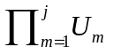, is implemented by one GRAPE coherent control pulse altogether, with a preset fidelity and a typical pulse length ranging from 10 ms to 15 ms. For the 25 snapshots of the dynamics, totally 25 GRAPE pulses are worked out, with their fidelities always set to be larger than 0.99. As a result, the technical complexity of the experiment decreases dramatically but the fidelity is maintained at a high level. The task of finding a GRAPE pulse itself may be fulfilled via feedback learning control¹⁹ that can exploit the quantum evolution of our NMR system itself. However, this quantum procedure is not essential or necessary in our experiment because here the GRAPE pulses on a 3-qubit system can be found rather easily.
(C) Measurement. To take the snapshots of the reaction process at t_{j} = jδt, we need to measure the overlaps of 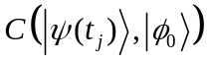 and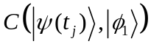. A full state tomography at t_{j} will do, but this will produce much more information than needed. Indeed, assisted by a simple diagonalization technique, sole population measurements already suffice to observe the reactant-to-product transformation (see Methods Summary).
To assess the difference between theory and experiment, we carry out one full state tomography for the final state density matrix at t = t_{f}. Because the GRAPE pulse is made to reach a fidelity larger than 0.995, the experimental density matrix 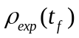 is indeed very close to the theoretical density matrix 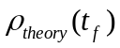obtained in an 8-dimensional Hilbert space, with a fidelity 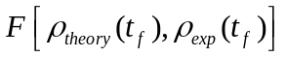 = 0.957. The experimental density matrix elements of the final state shown in Fig. 4b match the theoretical results to a high degree. With confidence in the experimental results on the full density matrix level, we can now examine the simulated reaction dynamics, reporting only the probabilities of the reactant and product states. Fig. 4c shows the time-dependence of the probabilities of both the reactant and product states obtained from our quantum simulator. It is seen that the product-to-reactant ratio increases continuously with time, with the probability of the product state reaching 77% at the end of the simulated reaction. At all times, the experimental observations of the reaction process are in impressive agreement with the smooth curves calculated theoretically on a classical computer. Further, the experimental results are also in qualitative agreement with the exact classical calculation using 64 grid points (see Fig. 1b). A prototype laser-driven reaction is thus successfully simulated by our 3-qubit system. We emphasize that due to the use of GRAPE pulses in synthesizing the gate operations, our simulation experiment lasts about 30 ms only, which is much shorter than the spin decoherence time of our system. The slight difference between theory and experiment can be attributed to imperfect GRAPE pulses, as well as inhomogeneity in RF pulses and in the static magnetic field.
Quantum simulation with only tens of qubits can already exceed the capacity of a classical computer. Before realizing general-purpose quantum algorithms that typically require thousands of qubits, a quantum simulator attacking problems not solvable on current classical computers will be one conceivable milestone in the very near future. The realization of quantum simulations will tremendously change the way we explore quantum chemistry in both stationary and dynamical problems^{10, 11}. Our work reported here establishes the first experimental study of the quantum simulation of a prototype laser-driven chemical reaction. The feasibility of simulating chemical reaction processes on a rather small quantum computer is hence demonstrated. Our proof-of-principle experiment also realizes a promising map from laser-driven chemical reactions to the dynamics of interacting spin systems under shaped RF fields. This map itself is of significance because it bridges up two research subjects whose characteristic time scales differ by many orders of magnitude.
Methods Summary
In order to obtain 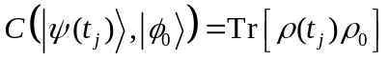 with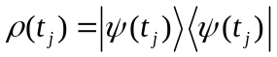, we first find a transformation matrix R to diagonalize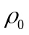, that is,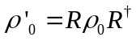, where 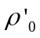 is a diagonal density matrix. Letting 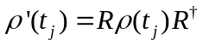 and using the identity 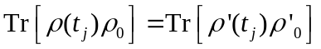, it becomes clear that only the diagonal elements or the populations of 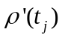 are required to measure 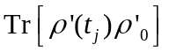, namely, the overlap . To obtain from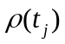, we simply add the extra R operation to the quantum gate network. The actual implementation of the R operation can be again mingled with all other gate operations using one GRAPE pulse. A similar procedure is used to measure.
The populations of can be measured by applying [𝜋/2]_{𝑦} pulses to the three qubits and then read the ensuing free induction decay signal. In our sample of natural abundance, only ∼ 1% of all the molecules contain a ¹³C nuclear spin. The signals from the ¹H and ¹⁹F nuclear spins are hence dominated by those molecules with the ¹²C isotope. To overcome this problem we apply SWAP gates to transmit the information of the ¹H and ¹⁹F channels to the ¹³C channel and then measure the ¹³C qubit.

1. Zalka, C. in ITP Conference on Quantum Coherence and Decoherence (Royal Soc. London, Santa Barbara, California, 1996), pp. 313-322.
2. Abrams, D. S., & Lloyd, S. Simulation of many-body Fermi systems on a universal quantum computer. Phys. Rev. Lett. 79, 2586 (1997).
3. Wu, L. A., Byrd M. S., & Lidar, D. A. Polynomial-time simulation of pairing models on a quantum computer. Phys. Rev. Lett. 89, 057904 (2002).
4. Smirnov, A. Y., Savelev, S., Mourokh, L. G., & Nori, F. Modelling chemical reactions using semiconductor quantum dots. Europhys. Lett. 80, 67008 (2007).
5. Lidar, D. A., & Wang, H. Calculating the thermal rate constant with exponential speedup on a quantum computer. Phys. Rev. E 59, 2429 (1999).
6. Peng, X. H., Du, J. F., & Suter, D. Quantum phase transition of ground-state entanglement in a Heisenberg spin chain simulated in an NMR quantum computer. Phys. Rev. A 71, 012307 (2005).
7. Somaroo, S., Tseng, C. H., Havel, T. F., Laflamme, R., & Cory, D. G. Quantum simulations on a quantum computer. Phys. Rev. Lett. 82, 5381 (1999).
8. Negrevergne, C., Somma, R., Ortiz, G., Knill, E., & Laflamme, R. Liquid-state NMR simulations of quantum many-body problems. Phys. Rev. A 71, 032344 (2005).
9. Friedenauer, A., Schmitz, H., Glueckert, J. T., Porras, D., & Schaetz, T. Simulating a quantum magnet with trapped ions. Nature Phys. 4, 757 (2008).
10. Aspuru-Guzik, A., Dutoi, A. D., Love, P. J., & Head-Gordon, M. Simulated Quantum Computation of Molecular Energies. Science 309, 1704 (2005).
11. Kassal, I., Jordan, S. P., Love, P. J., Mohseni, M., & Aspuru-Guzik, A. Polynomial-time quantum algorithm for the simulation of chemical dynamics. Proc. Natl. Acad. Sci. USA 105, 18681-18686 (2008).
12. Du, J. F., Xu, N. Y., Peng, X. H., Wang, P. F., Wu, S. F., & Lu, D. W. NMR implementation of a molecular hydrogen quantum simulation with adiabatic state preparation. Phys. Rev. Lett. 104, 030502 (2010).
13. Lanyon, B. P. et al., Towards quantum chemistry on a quantum computer. Nature Chem. 2, 106 (2010).
14. Nielson, M. A., & Chuang, I. L. Quantum Computation and Quantum Information (Cambrige Univ. Press, Cambridge, U. K., 2000).
15. Shor, P. in Proceddings of the 35th Annual Symposium on Foundations of Computer Science (IEEE Computer Society Press, New York, Santa Fe, NM, 1994), p. 124.
16. Buluta, I., & Nori, F. Quantum simulators. Science 326, 108 (2009).
17. Feynman, R. P. Simulating Physics with Computers. Int. J. Theor. Phys. 21, 467 (1982).
18. Lloyd, S. Universal Quantum Simulators. Science 273, 1073 (1996).
19. Rabitz, H., de Vivie-Riedle, R., Motzkus, M., & Kompa, K. Whither the future of controlling quantum phenomena? Science 288, 824 (2000); Warren, W. S., Rabitz, H., & Dahleh, M. Coherent control of quantum dynamics: the dream is alive. Science 259, 1581 (1993).
20. Rice S. A., & Zhao, M. Optical Control of Molecular Dynamics (John Wiley, New York, 2000); Shapiro M., & Brumer, P. Principles of the Quantum Control of Molecular Processes (John Wiley, New York, 2003).
21. Wang, D. A full dimensional, nine-degree-of-freedom, time-dependent quantum dynamics study for the H₂+C₂H reaction. J. Chem. Phys. 124, 201105 (2006).
22. Meyer H. -D., & Worth, G. A. Quantum molecular dynamics: propagating wavepackets and density operators using the multiconfiguration time-dependent Hartree method. Theor. Chem. Acc. 109, 251 (2003).
23. Dŏslić, N., Kühn, O., Manz, J., & Sundermann, K. The “Hydrogen-Subway”-A tunneling approach to intramolecular hydrogen transfer reactions controlled by ultrashort laser pulses. J. Phys. Chem. A 102, 9645 (1998).
24. Feit, M. D., Fleck, J. A. & Steiger, A. Solution of the Schrödinger equation by a spectral method. J. Comput. Phys. 47, 412 (1982).
25. Zhang, J. Z. H., Theory and Application of Quantum Molecular Dynamics (World Scientific, Singapore, 1999).
26. Cory, D. G., Fahmy, A. F., & Havel, T. F. Ensemble quantum computing by NMR spectroscopy. Proc. Natl. Acad. Sci. USA. 94, 1634 (1997).
27. Khaneja, N., Reiss, T., Kehlet, C., Herbrüggen, T. S., & Glaser, S. J. Optimal control of coupled spin dynamics design of NMR pulse sequences by gradient ascent algorithms. J. Magn. Reson. 172, 296 (2005).
28. Baugh, J. et al., Quantum information processing using nuclear and electron magnetic resonance: review and prospects. Phys. in Can. 63, No.4 (2007).
29. Ryan, C. A., Negrevergne, C., Laforest, M., Knill, E., & Laflamme, R. Liquid-state nuclear magnetic resonance as a testbed for developing quantum control methods. Phys. Rev. A 78, 012328 (2008).

Supplementary Information is linked to the online version of the paper at www.nature.com/nature.
Acknowledgements Helpful discussions with J. L. Yang are gratefully acknowledged. This work was supported by National Nature Science Foundation of China, the CAS, and the National Fundamental Research Program 2007CB925200.
Author Information Reprints and permissions information is available at www.nature.com/reprints. The authors declare no competing financial interests. Correspondence and requests for materials should be addressed to J.D. (djf@ustc.edu.cn).

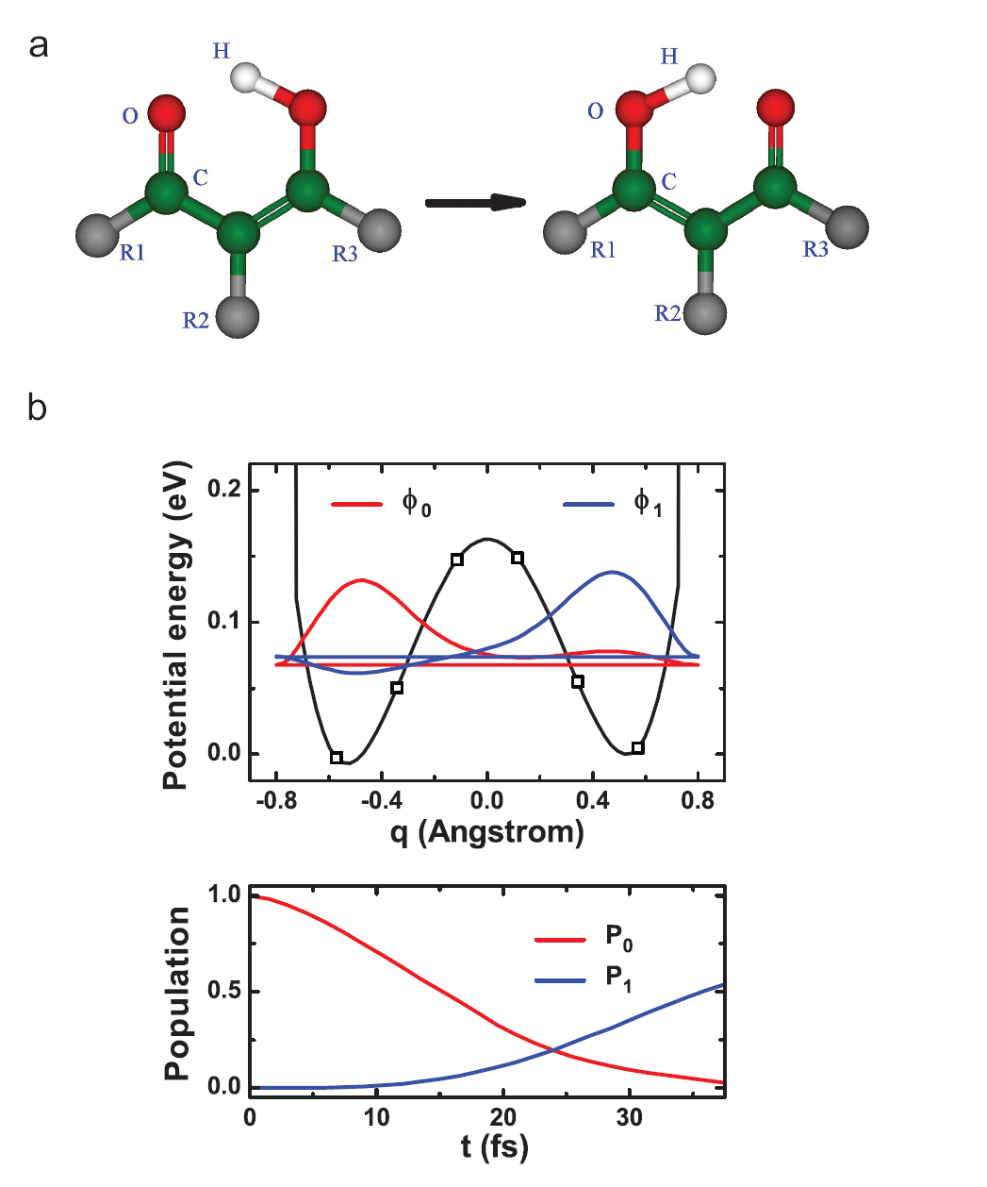
Figure. 1| Prototype chemical reaction and potential energy curve. a, Isomerization reaction of nonsymmetric substituted malonaldehydes. b, Upper panel: Potential energy curve, together with the eigenfunctions of the ground (red) and the first excited (blue) states. The main system parameters [(Eq. 2)] are taken from Ref. [23], with V⁺ = 0.00625 E_{h}, Δ = 0.000257 E_{h}, and q = 1 a₀. As a modification, the potential values for q approaching the left and right ends are increased sharply to ensure rapid decay of the wavefunction amplitudes. In particular, this procedure increases the V value at q = ±0.8Å by a factor of 30. The six discrete squares shown on the potential curve and the two end points at q = ±0.8Å constitute the 8 grid points for our 3-qubit encoding. Lower panel: Numerically exact time-dependence of populations of the ground state (reactant state, denoted P₀) and the first excited state (product state, denoted P₁).

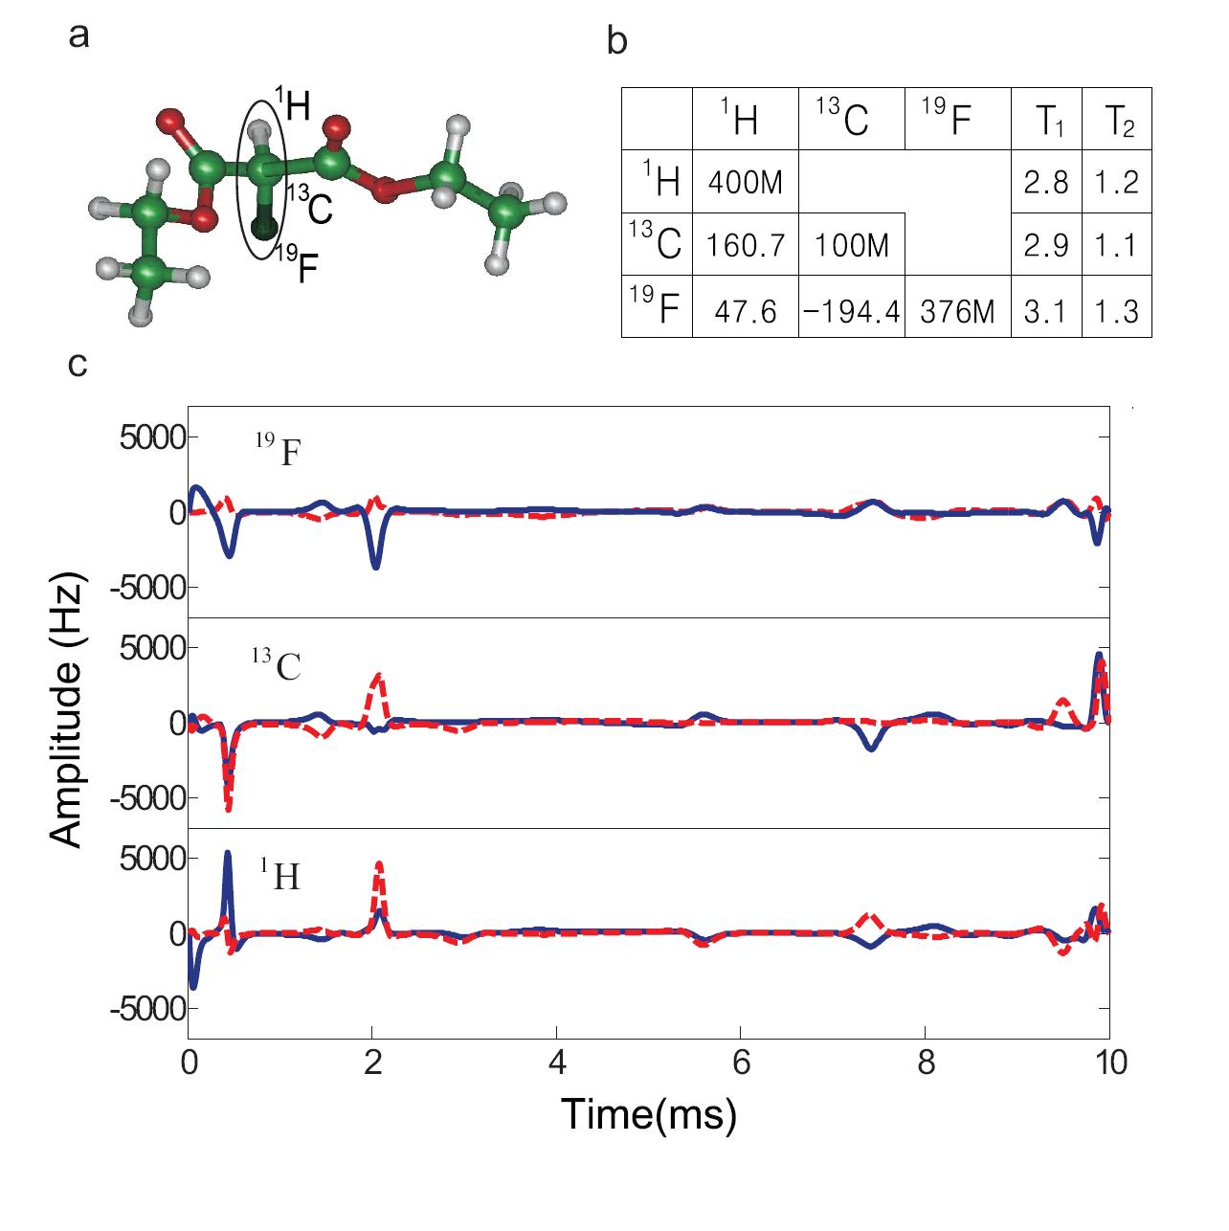
Figure. 2| Sample and technique used in the experiment. a, Molecular structure of Diethyl-fluoromalonate. The ¹H, ¹³C and ¹⁹F nuclear spins marked by oval are used as three qubits. b, System parameters and important time scales of Diethyl-fluoromalonate. Diagonal elements are the Larmor frequencies (Hz) and off-diagonal elements are scalar coupling strength (Hz) between two nuclear spins. Relaxation and dephasing time scales (second) 𝑇₁ and 𝑇₂ for each nuclear spin are listed on the right. c, The GRAPE pulse that realizes the initial state from the PPS |000⟩, with a pulse width 10 ms and a fidelity over 0.995. The (blue) solid line represents the pulse power in 𝑥-direction, and the (red) dotted line represents the pulse power in 𝑦-direction. The three panels from top to bottom represent the RF features at three central frequencies associated with the ¹⁹F, ¹³C and ¹H spins, respectively.

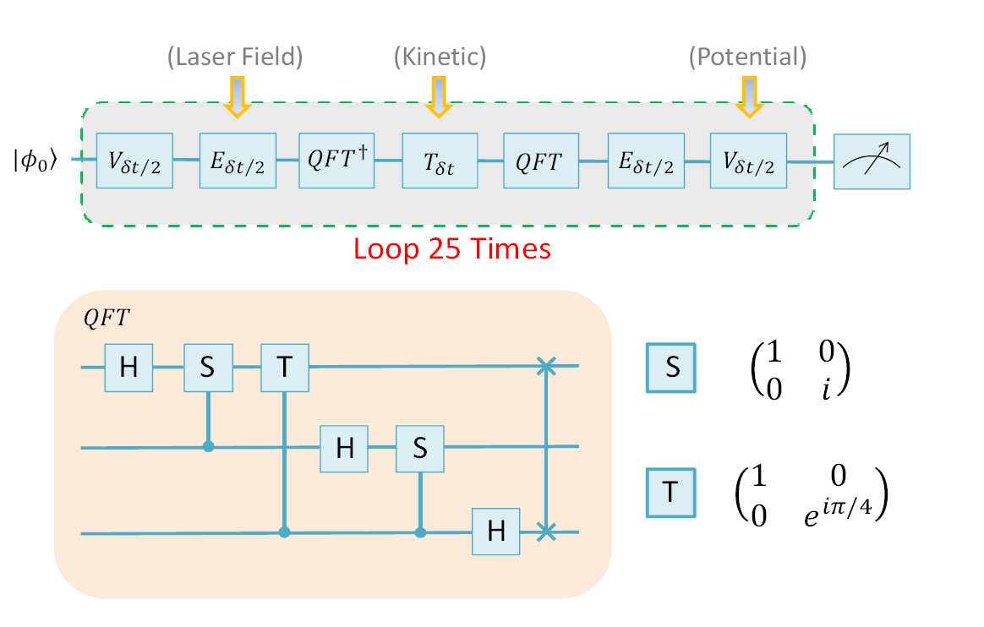
Figure. 3| Quantum network to simulate the chemical reaction dynamics. Upper panel: The network of quantum operations to simulate the chemical reaction dynamics, with the reactant state . The whole process is divided into 25 loops. The operators , and are assumed to be in their diagonal representations. Lower panel: H is the Hadamard gate and S, T are phase gates as specified on the right. Vertical lines ending with a solid dot represent controlled phase gates and the vertical line between two crosses represents a SWAP gate.

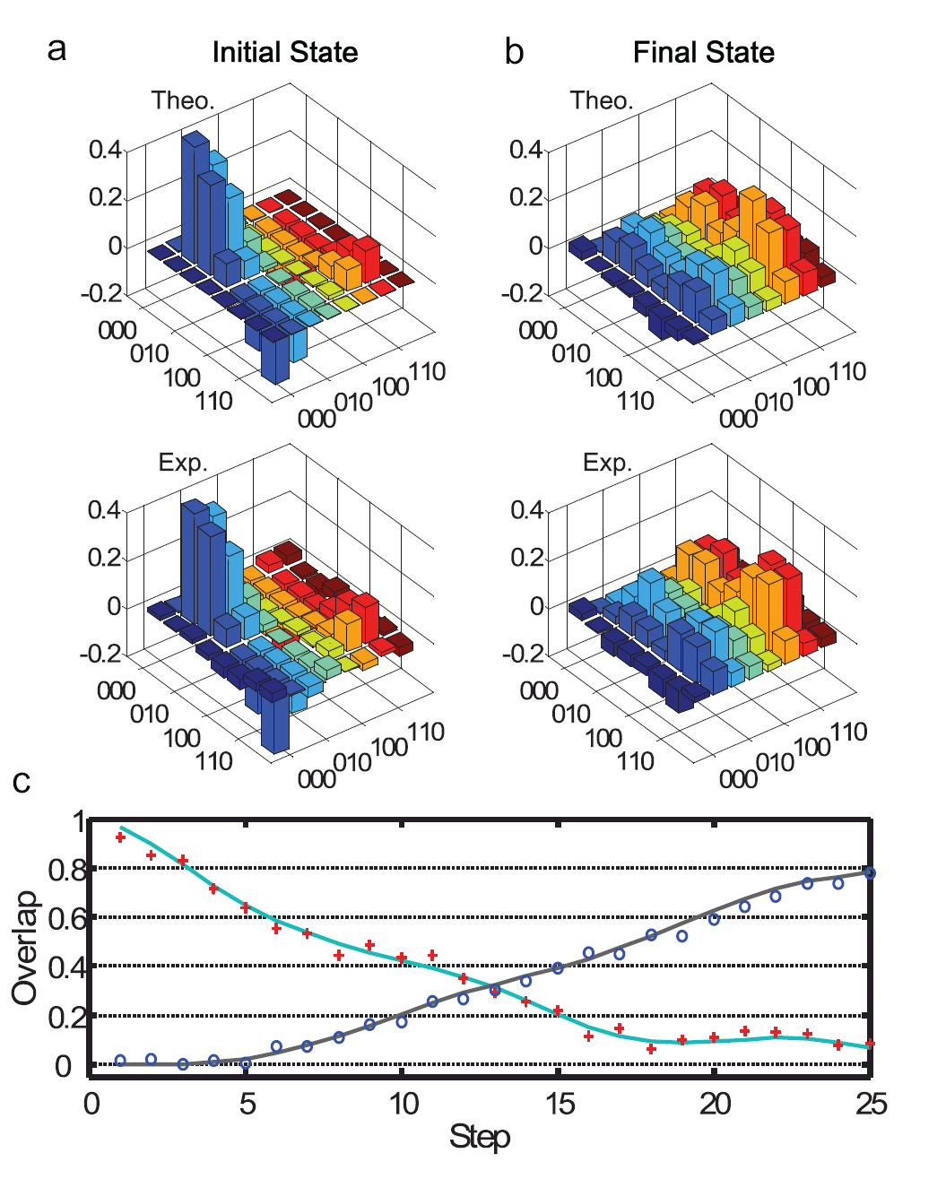
Figure. 4| Experimental tomography results and the reaction dynamics obtained both theoretically and experimentally. a-b, Real part of the density matrix of the initial and final states of the simulated reaction. Upper panels show the theoretical results based on an 8-dimensional Hilbert space, and lower panels show the experimental results. c, The measured probabilities of the reactant and product states to give 25 snapshots of the reaction dynamics. The (red) plus symbols represent measured results of and the (blue) circles represent measured results of , both in agreement with the theoretical smooth curves. Results here also agree qualitatively with the numerically exact dynamics shown in Fig. 1b.

